CONSTITUTION & BY-LAWS
DEEP LAKE IMPROVEMENT ASSOC.

Deep Lake Improvement Association is a volunteer organization dedicated to maintaining the quality of Deep Lake through maintenance of our lake, which includes weed abatement, fish stocking and general education and safety of Deep Lake. We accomplish this through our annual optional membership and fundraising.

BY-LAW ARTICLE 1 MEMBERSHIP

Section 1. Members shall be any dues-paying property owner or permanent resident of such property residing within the designated boundaries.
Section 2. All members shall be active members; they shall pay full dues and shall have the rights and privileges of membership.

ARTICLE 2 BOARD OF MANAGERS

Section 1. The members of the Board of Managers will be a President, Vice-President, Secretary, Treasurer, Planning Commissioner, and Area representatives of each area of the lake which includes East Shore, Deep Lake Shores and Ishnala Estates.
Section 2. The control and management of this association shall be vested in the Board of Managers. Vacancies on the Board shall be filled by the vote of the Board at a regularly scheduled meeting and shall be valid only until the next annual meeting.
Section 3. It shall be the duty of the President to preside at all meetings of the Association and Board of Managers. The President shall approve all orders drawn on the Treasury which have been approved by action of the organization in a stated business meeting or by order of the Board of Managers.
Section 4. It shall be the duty of the Vice President to perform the duties of the President in absence or inability to serve. The Vice President will automatically assume the post of President in the event the President cannot fulfill the full term.
Section 5. The Secretary shall keep the minutes of the Association and of the Board of Managers in books which shall be the property of the Association and have access at all reasonable times or places. The Secretary or Treasurer shall collect all dues and issue boat launch and beach keys, notify members of their election to office, keep a roll of members and offices and, prepare other correspondence as directed by the President or Board of Managers.

Section 6. The Treasurer shall be the custodian of all monies of the Association and shall pay expenses authorized by the Association or Board of Managers, in session. The Treasurer shall file expenses and keep account of receipts and expenditures in books belonging to the Association and open to the inspection of the authorized officials at all reasonable times.
The Treasurer shall make monthly reports to the Board of Managers and give a full report at year end. The Treasurer shall be responsible for the annual renewal of the Articles of Incorporation with the State of Illinois.
The Treasurer shall pass to an elected successor all funds, books, and papers belonging to the Association within thirty days of the annual meeting.
Section 7. The Board of Managers shall be informed of all State and County laws and regulations pertaining to the health and welfare of the lake and shall make every effort towards correcting undesirable community conditions. The maintenance of all Association property, such as piers and beaches, shall be under their jurisdiction.
Section 8. The Planning Commissioner shall be responsible for all fundraising events that will attract or earn additional revenue for the lake.

ARTICLE 3 DUES

Section 1. The annual dues and fees shall be determined by the Board of Managers.
Section 2. The payment of dues reflects the members’ concern for the welfare of the lake.
Section 3. Failure to pay dues forfeits all membership rights and its privileges.

ARTICLE 4 MEETINGS

Section 1. Regular meetings of the Board of Managers shall be held each month, February through October and such other times as may be agreed upon by its members.
Section 2. Special meetings of the Board of Managers may be called by the President or three members of the Board of Managers. All members to be notified and the object of the meeting stated.
Section 3. The annual meeting of the Association shall be held at a time when maximum attendance can be encouraged.
Section 4. A special meeting of the Association in general may be called by the President or may be called upon the request of twenty members. All members to be notified and the object of the meeting stated.

ARTICLE 5 QUORUM

Section 1. After due notification, meetings of two thirds of the Board of Managers shall constitute a quorum for the transaction of business. The simple majority vote rules.
Section 2. Any member may attend meetings of the Board of Managers and may offer suggestions or supply pertinent information.

ARTICLE 6 NOMINATIONS & ELECTIONS

Section 1 At the annual meeting, dues paying members may submit a nomination form for the following positions.
- President
- Vice President
- Secretary
- Treasurer
- Planning Commissioner
- Area Commissioner, East Shore
- Area Commissioner, Deep Lake Shores
- Area Commissioner, Ishnala Estates

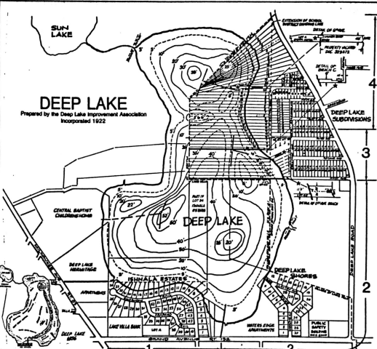

.

The Board of Managers are to be elected for a two-year term or until successors are elected and qualified. A further provision is that no more than five elected officers may reside on lakefront property.
Section 2 A list of nominees shall be sent to each member with the call for the annual meeting. All nominees shall be dues-paying members.
Section 3 Nominations from the floor may be made at the annual meeting. No one shall be nominated whose consent to serve has not been first obtained.
Section 4 The election shall take place at the annual meeting. If there is more than one candidate for office, the vote must be by ballot.

Article 7 AMENDMENTS

These bylaws may be amended at any regular meeting or special meeting called for that purpose by two thirds vote of those present after previous notice had been given.

Article 8 PARLIAMENTARY AUTHORITY

Robert’s Rules of Order shall be the parliamentary authority in all matters not specified in the bylaws or standing rules of this organization.

